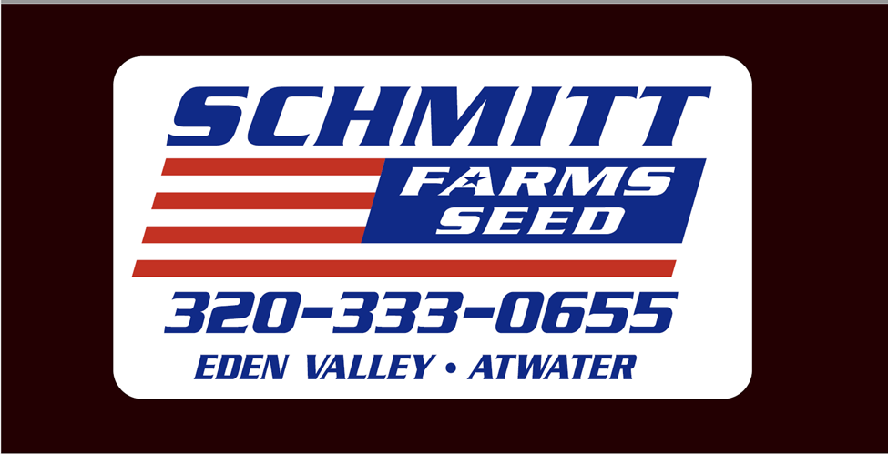



**of Grove City**

**320-857-2741**

**snacks *gas * pop *pizza *subs *coffee**

**Make Schmidty’s Your First Stop!**

**==================================**

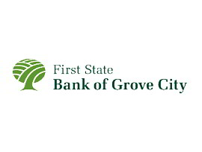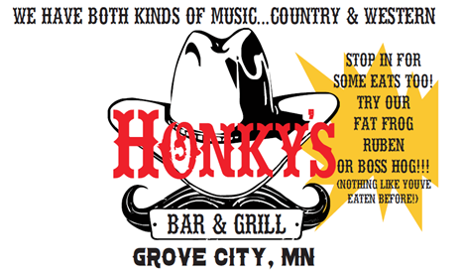

Over 100 years of Service

110 Atlantic Avenue West

Grove City, MN 56243

320-857-2521

 Don’t forget the bus runs through Grove City. We would like to see more people using this source of transportation. Contact Contact the Care office for **tokens & punch cards.**

__________________________________



**Since 1913**

Custom Processing

Frozen Meat Sales

USDA Inspected Est.

Homemade sausages-(beef, pork, & buffalo)

**Charles Carlson**

105 N. 2nd St. Grove City, MN



Travis Weseman [Travis@201buildingsupply.com](mailto:Travis@201buildingsupply.com)

201 Pacific Ave / Grove City, MN 56243

Phone: 320-857-2031 / Fax: 320-857-2033





We are partnered with both!

They help with nursing services, home health aide, homemaker, companionship, hospice, and so much more.